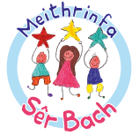
Newid Manylion/Change of Details
Enw plentyn/Name of Child……………………………………………
Dyddiad geni/DoB………………………

Newid cyfeiriad/Change of address
Newid enw /Change of name
Newid rhif ffôn
/Change of telephone number
Newid e-bost
/Change of email
Newid man gwaith i riant /Change place of work for a parent  (cofiwch gynnwys enw'r cwmni, cyfeiriad a rhif cyswllt, e-bost) (please include name of company, address and contact number, email) | Perthynas â'r plentyn /Relationship to child:-
Newid manylion cysylltiadau brys Enw /Change details of emergency contacts
Name
Cyfeiriad/Address

Rhif ffôn
/Tel no

